PIZZA SALES SQL QUERIES  
SQL Project

A. KPI

1.Total Revenue:  
select sum(total_Price) total_revenue from pizza_sales;  
  
2.Average Order Value:  
select sum(total_price)/ count(distinct order_id) as avg_order_value from pizza_sales;  
  
3.Total Pizzas Sold  
select sum(quantity) total_pizzas_sold from pizza_sales;  
  
4.Total Orders  
select count(distinct order_id) Total_Orders from pizza_sales;   
  
5. Average Pizzas per Order

select sum(quantity) /count(distinct order_id) avg_pizza_sold_perOrder from pizza_sales;

6. Average Pizzas per Order  
  
B. Daily Trend for Total Orders:  
  
select DATENAME(DW, order_date) as order_day, count(distinct order_id) as total_orders from pizza_sales group by DATENAME(DW, order_date);  
  
C. Hourly Trend for Total Orders:  
  
select DATEPART(HOUR,order_time) as order_hours, count(distinct order_id) as total_orders from pizza_sales

group by DATEPART(HOUR,order_time)

order by DATEPART(HOUR,order_time);   
  
D. Percentage of Sales of the Pizza Category:

select pizza_category ,sum(total_price) as total_sales, sum(total_price) * 100 / (select sum(total_price) from pizza_sales) as percentOf_total_sales

from pizza_sales

group by pizza_category;   
E. Percentage of Sales of the Pizza Size:  
select pizza_size ,sum(total_price) as total_sales, sum(total_price) * 100 / (select sum(total_price) from pizza_sales) as percentOf_total_sales

from pizza_sales

group by pizza_size;  
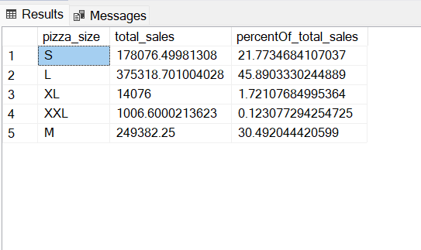  
F. Total Pizza sold by pizza category:

select pizza_category,sum(quantity) as tot_pizza_sold from pizza_sales

group by pizza_category;  
  
G. Top 5 Best sellers by Total Pizzas Sold:  
  
select top 5 pizza_name, sum(quantity)as tot_Pizza_Sold from pizza_sales

group by pizza_name

order by tot_Pizza_Sold desc;

H. Bottom 5 worst seller by Total Pizza sold:  
  
select top 5 pizza_name, sum(quantity)as tot_Pizza_Sold from pizza_sales

group by pizza_name

order by tot_Pizza_Sold asc;  
